**sWeek-11**

**DLD LAB-11**

**Multiplexer and Demultiplexer & Encoder and Decoder**

**Objectives:**

* To understand concept of Multiplexer and Demultiplexer & Encoder and Decoder circuits.
* To validate implementation of circuits using **Circuit Maker 2000**.

**Multiplexer and Demultiplexer**

**What is a Multiplexer?**

The multiplexer is a device that has multiple inputs and single line output. The select lines determine which input is connected to the output, and also increase the amount of data that can be sent over a network within a certain time. It is also called a data selector.

The multiplexer is used to perform **high-speed switching** and is constructed by [electronic components](https://www.elprocus.com/basic-components-used-electronics-electrical/).

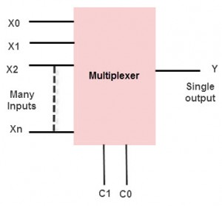

**Multiplexer Types**

Multiplexers are classified into four types:

* 2-1 multiplexer (1 select line)
* 4-1 multiplexer (2 select lines)
* 8-1 multiplexer (3 select lines)
* 16-1 multiplexer (4 select lines)

#### **4-to-1 Multiplexer**

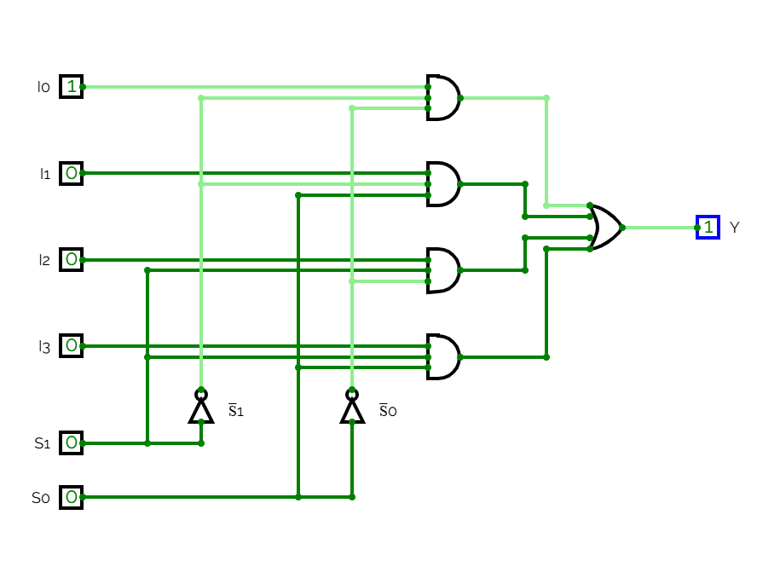

**Truth Table (4-1 Multiplexer):**

|  |  |  |
| --- | --- | --- |
| **S₁** | **S₀** | **Output Y** |
| 0 | 0 | I0 |
| 0 | 1 | I₁ |
| 1 | 0 | I₂ |
| 1 | 1 | I₃ |

**Circuit Diagram (4-1 Multiplexer):**

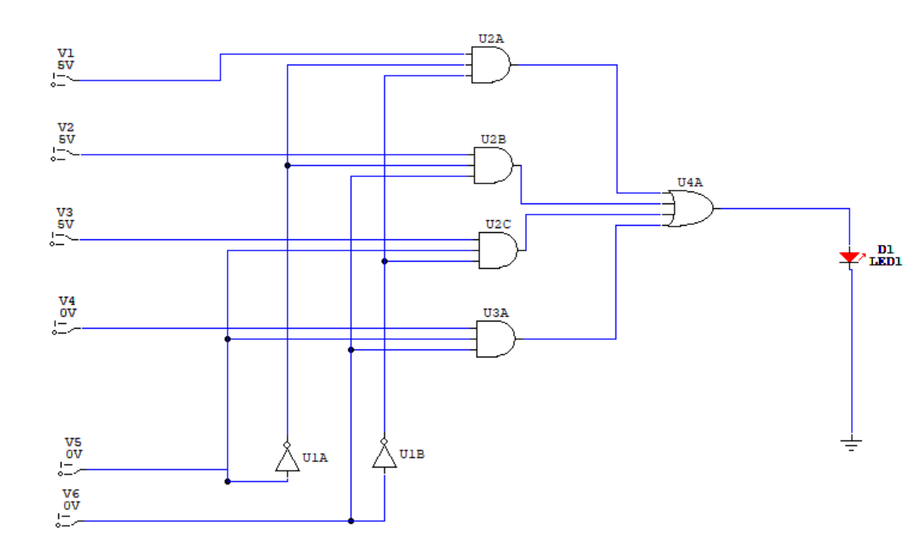

**What is a De-Multiplexer?**

De-multiplexer is also a device with one input and multiple output lines. It is used to send a signal to one of the many devices. The main difference between a multiplexer and a de-multiplexer is that a multiplexer takes two or more signals and encodes them on a wire, whereas a de-multiplexer does reverse to what the multiplexer does.

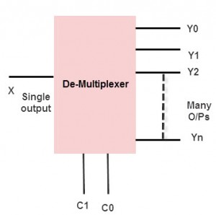

**De-Multiplexer Types**

Demultiplexers are classified into four types

* 1-2 demultiplexer (1 select line)
* 1-4 demultiplexer (2 select lines)
* 1-8 demultiplexer (3 select lines)
* 1-16 demultiplexer (4 select lines)

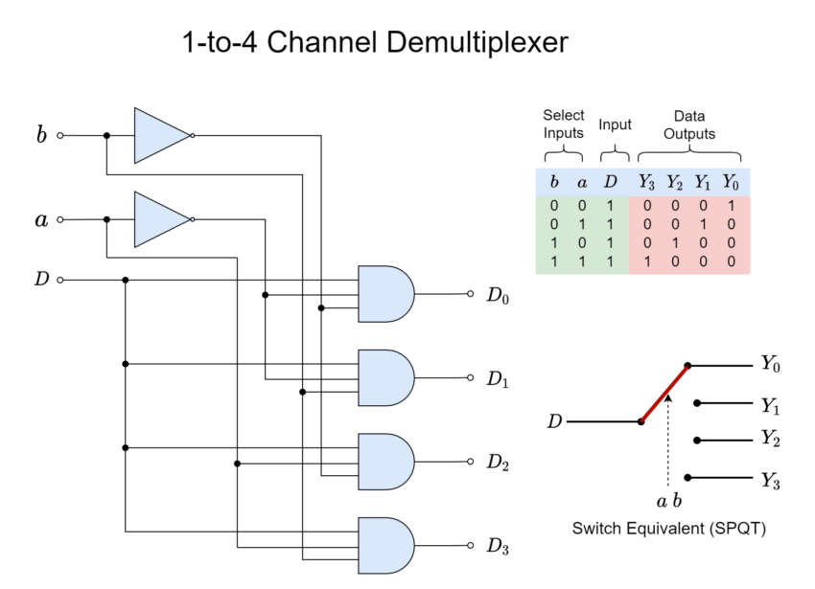

**Truth Table (1-4 De-Multiplexer):**

|  |  |  |  |  |  |
| --- | --- | --- | --- | --- | --- |
| **S₁** | **S₀** | **Y₀** | **Y₁** | **Y₂** | **Y₃** |
| 0 | 0 | **D** | 0 | 0 | 0 |
| 0 | 1 | 0 | **D** | 0 | 0 |
| 1 | 0 | 0 | 0 | **D** | 0 |
| 1 | 1 | 0 | 0 | 0 | **D** |

**Circuit Diagram (1-4 De-Multiplexer):**

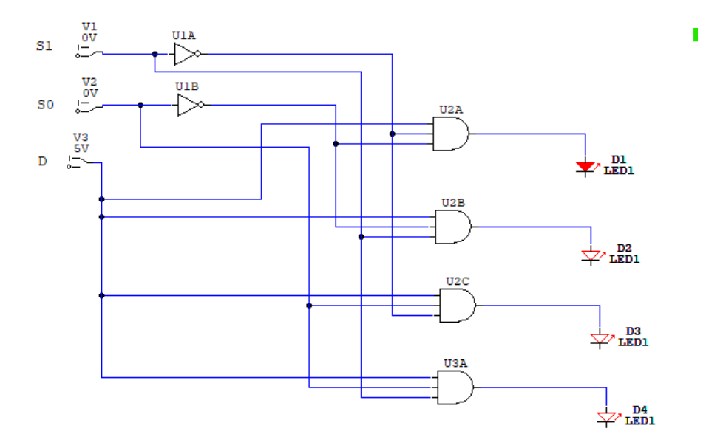

**Encoder and Decoder**

**What is Encoder:**

An encoder in digital electronics is a combinational circuit that has 2 to the power n inputs and n outputs. The encoder produces a [#binary](https://www.learnelectronicsindia.com/electronic-blogs/hashtags/binary) code equivalent to the given input. The [#encoder](https://www.learnelectronicsindia.com/electronic-blogs/hashtags/encoder) encodes information from 2n inputs to n outputs.

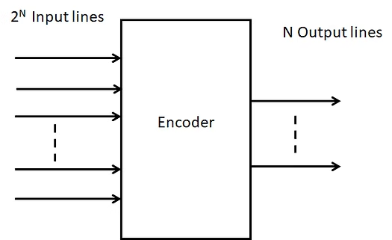

**Types of Encoders**

**(4 to 2 line) encoder:**

4 can be written as 2^2 so the inputs are 4 and the outputs are 2. Let the outputs be A1 and A0 and the inputs be Y3, Y2, Y1, Y0. At any time, any one of the inputs will be 1 and the respective Binary code will be the output.

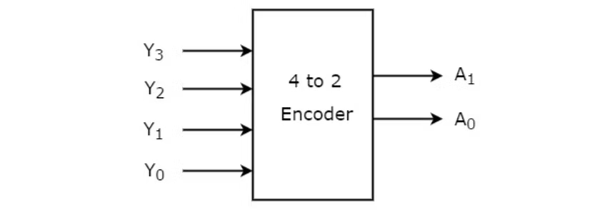

**The following is the truth table of 4 to 2 encoder:**

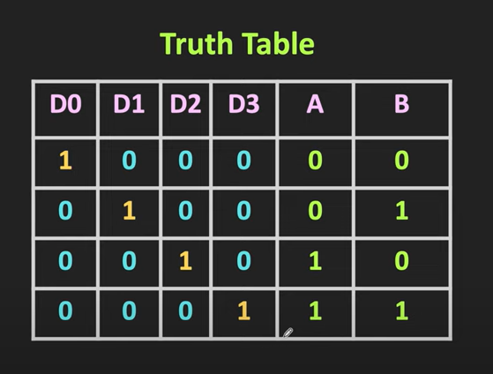

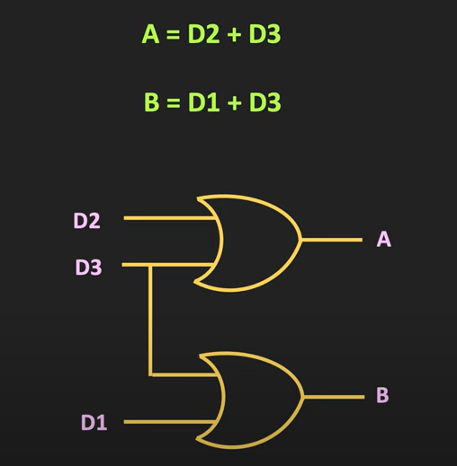

**(8 to 3 line) encoder:**

(8 to 3) line encoder has 8 inputs and 3 outputs. It is also known as [Octal](https://www.learnelectronicsindia.com/electronic-blogs/hashtags/octal) to Binary encoder. Let the inputs be Y7, Y6, Y5, Y4, Y3, Y2, Y1, Y0, and the inputs be A2, A1, and A0. One of the 8 inputs is set to 1 to get the respective Binary code as output.

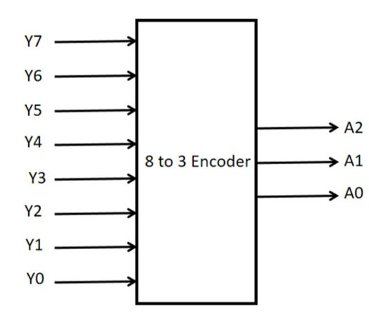

**The following is the truth table of 8 to 3 encoder:**

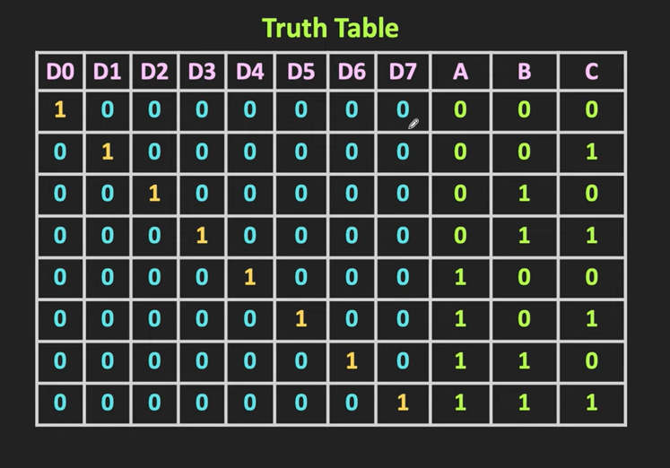

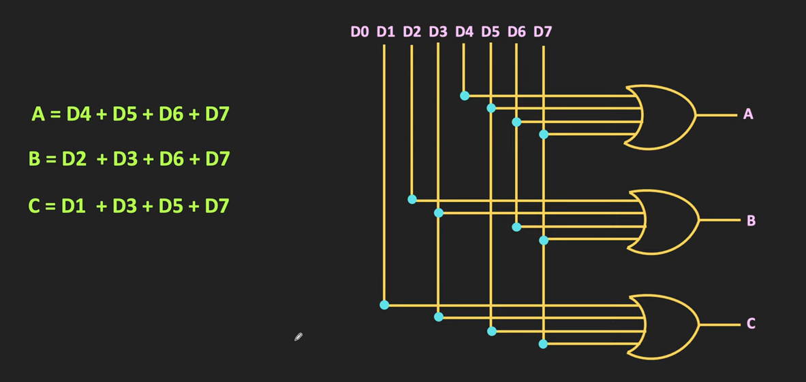

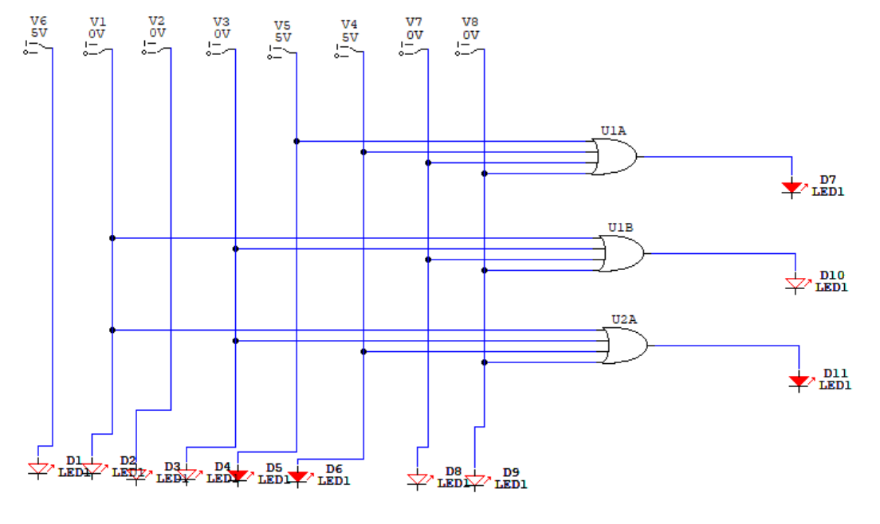

**Decimal to BCD Encoder:**

BCD is a **Binary Coded Decimal**. The decimal to [#BCD](https://www.learnelectronicsindia.com/electronic-blogs/hashtags/BCD) encoder has ten(10) input lines and four(4) output lines. Each decimal digit is each input to ten input lines and the output at the four output lines is the BCD code. Decoded decimal data is given as input to this encoder and it encodes the given input to BCD output; the output is available at the output lines.

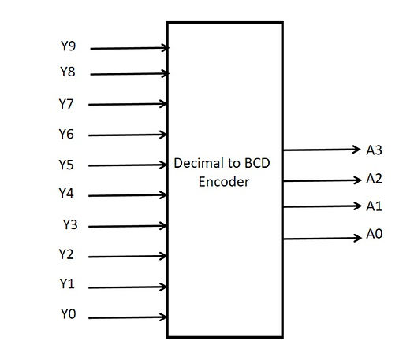

**The following is the truth table of the Decimal to BCD encoder:**

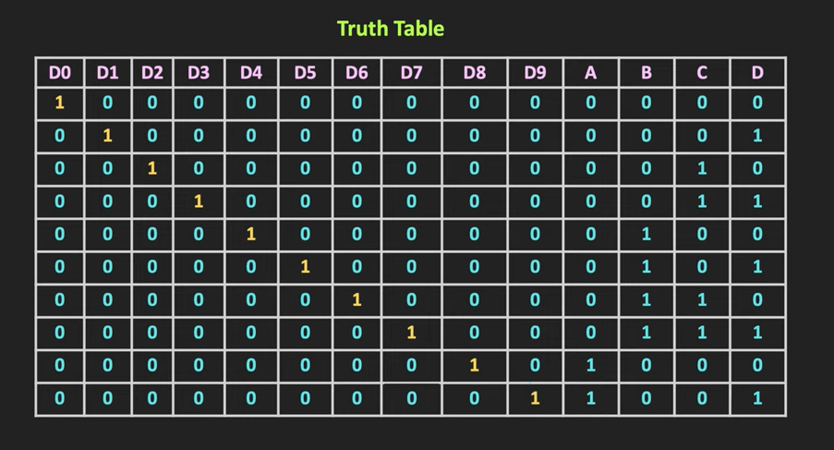

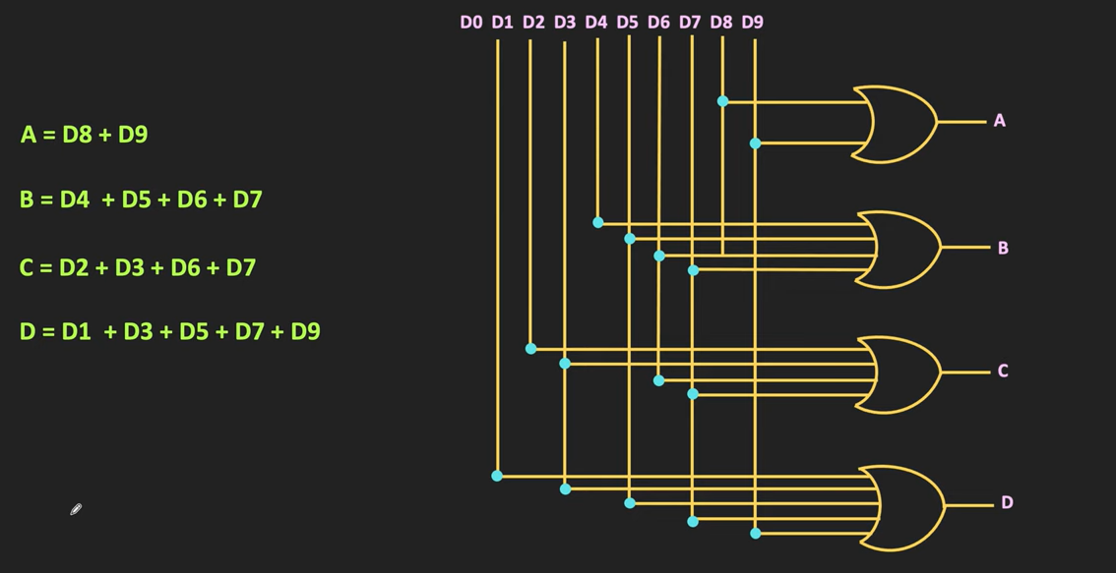

**What is Decoder:**

In digital electronics, a combinational logic circuit that converts an **N-bit binary** input code into M output channels in such a way that only one output channel is activated for each one of the possible combinations of inputs is known as a **decoder**.

In other words, a combinational logic circuit which converts N input lines into a maximum of 2N output lines is called a **decoder**.

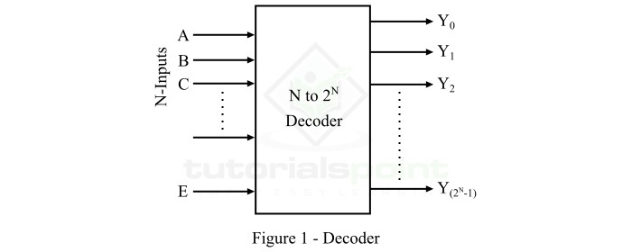

**Types of Decoders**

There are several types of decoders present. But, based on the input and output lines present, decoders may be classified into the following three types:

* 2 to 4 Decoder
* 3 to 8 Decoder
* 4 to 16 Decoder

**2 to 4 Decoder**

The 2 to 4 decoder is one that has 2 input lines and 4 (22) output lines. The functional block diagram of the 2 to 4 decoder is shown below. **E is enabling input**.

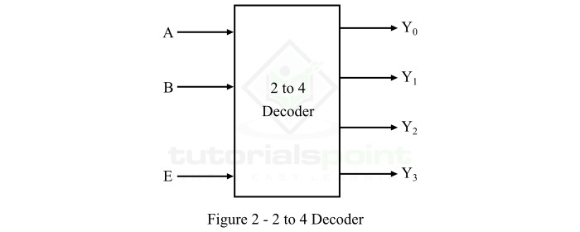

**Truth Table:**

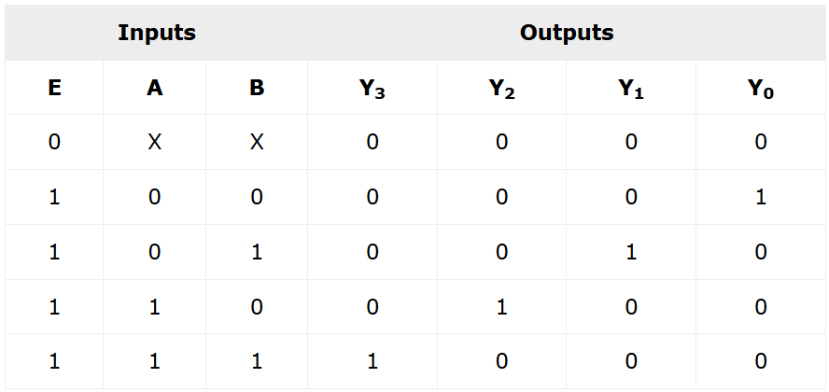

**Expression:**

Using this truth table, we can derive the Boolean expression for each output as follows:

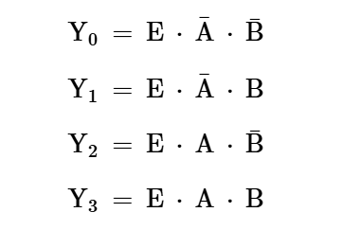

**Circuit Diagram:**

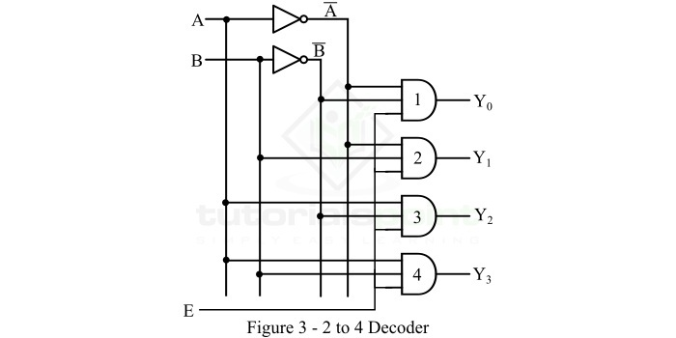

**3 to 8 Decoder**

The 3 to 8 decoder is one that has 3 input lines and 8 (23) output lines. The functional block diagram of the 3 to 8 decoder is shown below.

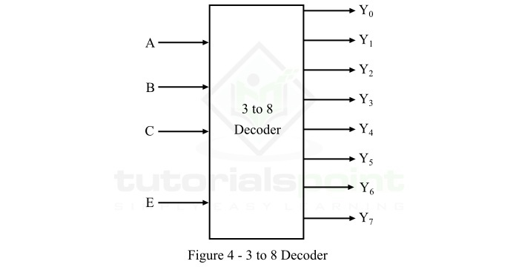

**Truth Table:**

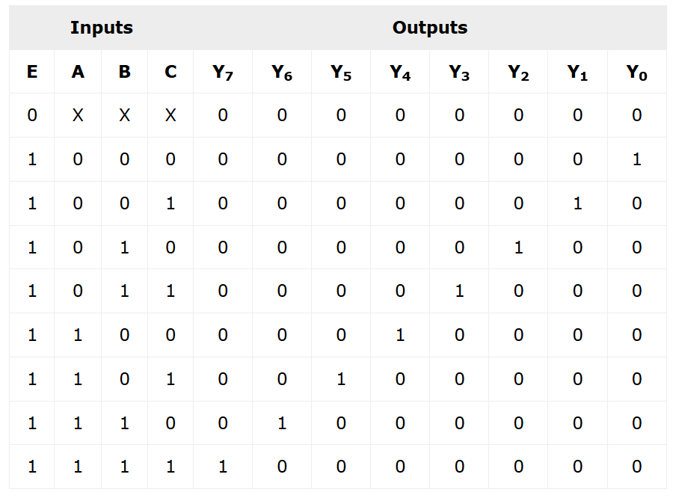

**Expression:**

Using this function table, we can derive the Boolean expression for each output as follows:

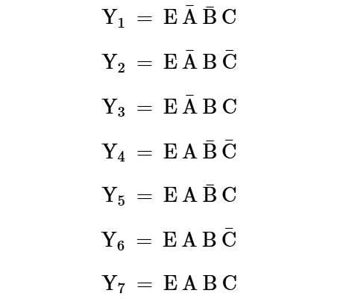

**Circuit Diagram:**

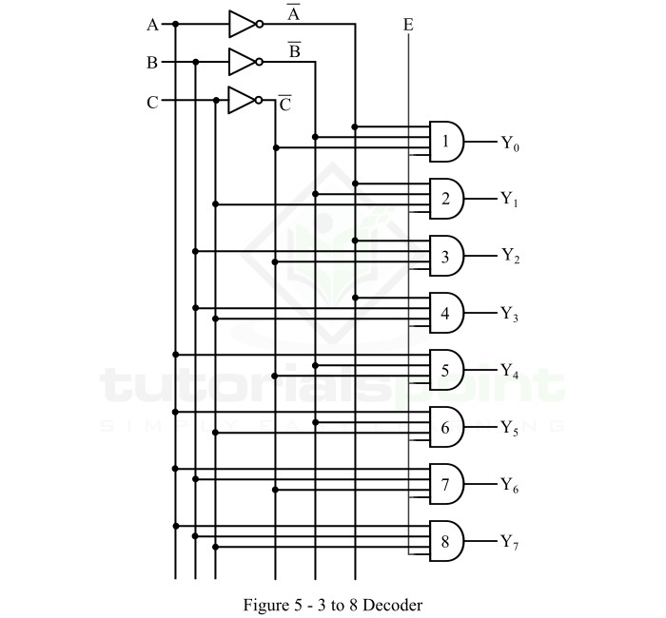

**4 to 16 Decoder**

The 4 to 16 decoder is the type of decoder which has 4 input lines and 16 (214) output lines. The functional block diagram of the 4 to 16 decoder is shown below.

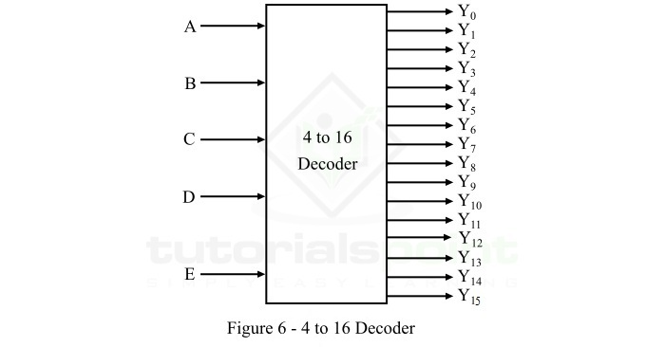

**Truth Table:**

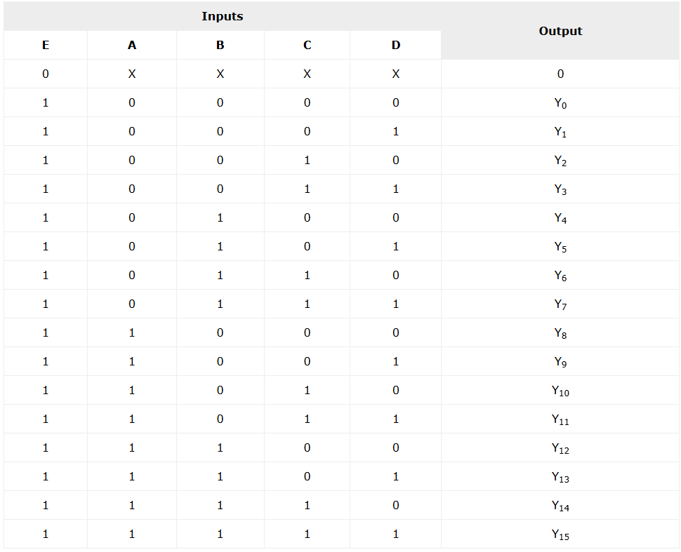

**Expression:**

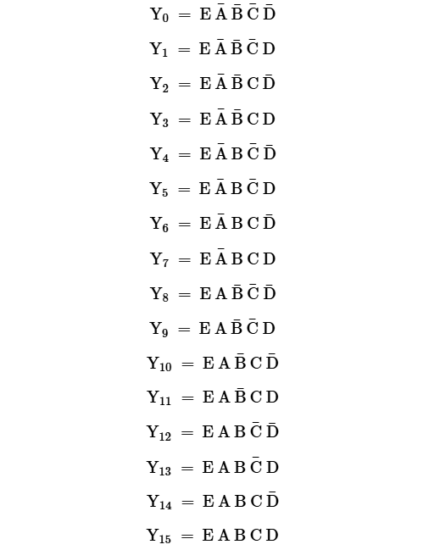

**LAB TASKS**

**TASK-01**

**Implement all Multiplexer and De-multiplexer circuits on Circuit Maker and paste your screenshots here.**

**Solution:**

**Multiplexer** 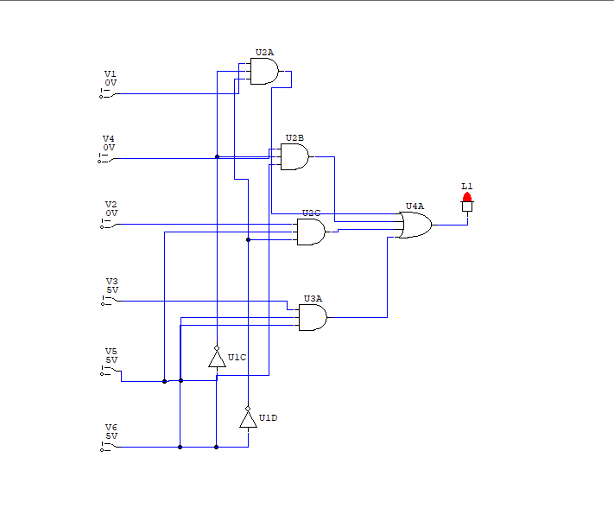

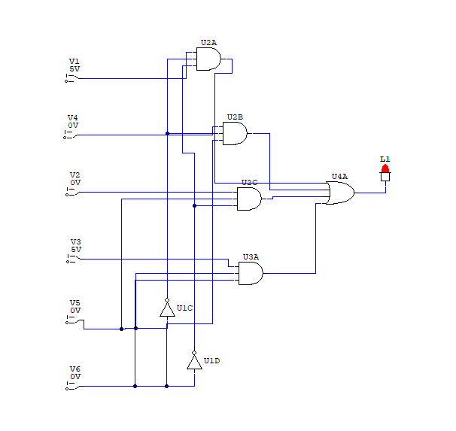

**De-multiplexer**

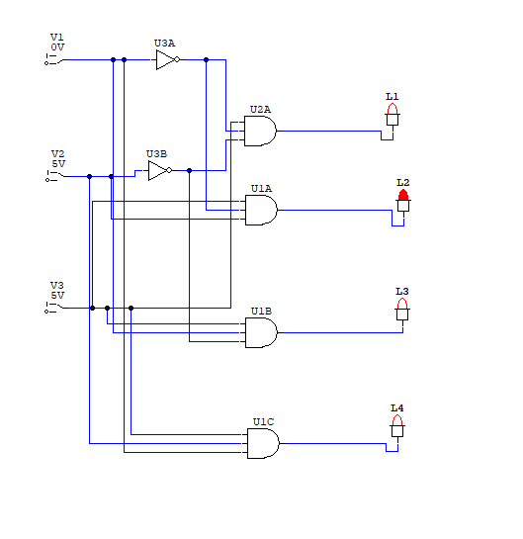 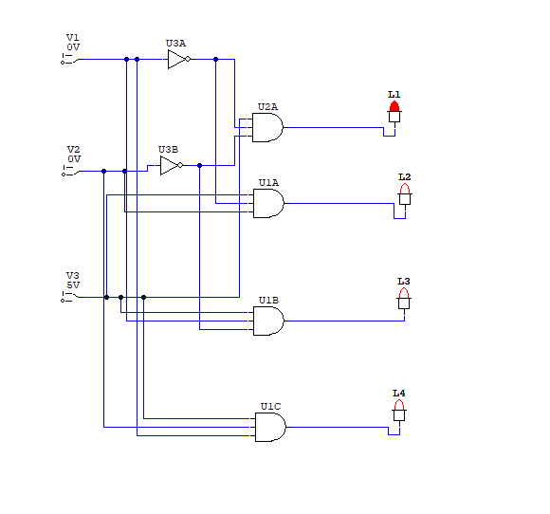 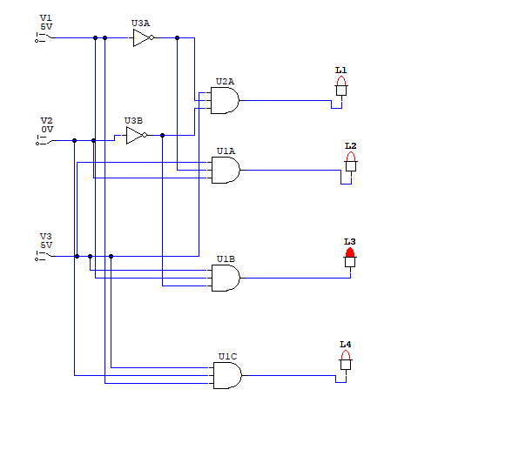

**TASK-02**

**Implement all encoders and decoders circuits on Circuit Maker and paste your screenshots here.**

**Solution:**

Encoders

